Detailed steps and analysis for the Data Preparation and Quality section:
Element considered | Description | Fields that posed challenges | Steps taken in this assignment
Column header consistency | Data errors, such as mislabelled data can occur in big data processes (Sharifnia et al., 2025). | Airport_fee vs airport_fee | The column name was adjusted in the minority files, which was 35 out of the 144 files.
Missing data | Missing values are an important part of the preparation process to identify incomplete records that can lead to accuracy and reliability issues (Sharifnia et al., 2025). | 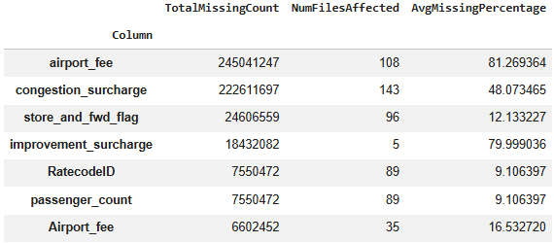 | airport_fee: the missing values were treated as indicating that no airport fee was applicable.  congestion_surcharge: the missing values were treated as indicating no surcharge applied.  store_and_fwd_flag: this variable was left unchanged it is not critical to the primary analysis of the assignment.  Improvement_surchare: This field was only missing in 5 files and indicated a high proportion of missingness. It was decided to keep this as is, but to note the months where this field did not populate appropriately.  RatecodeID: The missing values will be interpreted as an “unknown” category and not removed from the dataset.  Passenger_count: the missing value records were retained but analysis involving this field will exclude trips with missing values.
Record count | To verify dataset completenes and insight into size over time, record counts were reviewed (Sharifnia et al., 2025). | A significant decreasing trend is observed in number of records in the data over the years. Low volumes are especially observed in 2020, which correlates with the COVID pandemic.The years besides 2020 might be due to less demand for night time taxis, or more competitors in the market, it might even be other external factors, like a train built within the past few years, better bus services, etc. | The reason for the decrease might be external to the dataset. No action was taken.
Inconsistency: pickup and dropoff sequence per trip | Noisy data detection was applied to identify inconsistent sequences of events. Noisy data detection is important in the data preparation phase (Sharifnia et al., 2025). | A low proportion of records were observed with inconsistent timestamp sequences. | The inconsistency was picked up across 42 files with 3 instances where the proportion was more than 5%. This can be viewed as small enough to leave as is.
Duplicate records | To ensure data quality and analytical accuracy, duplicate records were investigated (Sharifnia et al., 2025). | Low volume of possible duplicate records were observed. | The nature of the data makes it difficult to identify duplicate records as no unique identifier is provided per driver, vehicle or passenger. No records were deleted.
Outliers in numerical fields | Outlier detection is used to identify data points that differ significantly from the majority observations. The technique suggested by Sharifnia et al., 2025 was applied to perform detection by making use of the Z-scores of each numerical variable. | 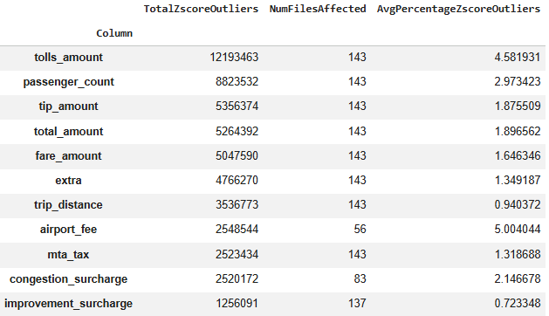 | Z= 3 was used to indicate an outlier. There are 2 variables that show 5%+ outlier proportions, namely tolls_amount and airport_fee.  Airport_fee only experienced outliers in 56 of the files, whereas tolls_amount was found in all files.  After investigating the airport_fee, it increased from the beginning of 2023.
Zero-value anomalies | Identify impossible or suspicious zero values and investigate whether they are valid observations or data quality issues requiring correction during data cleaning (Sharifnia et al., 2025). | 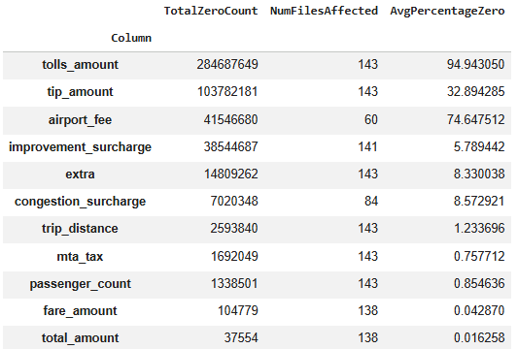 | tolls_amount: this was expected as not all taxi ride involve paying tolls.  Tip_amount: tipping is not mandatory and therefore it is expected to have a high proportion zeros.  Airport_fee: this was another expected one as not al taxis go to the airport.  improvement_surcharge (5.79% zero), extra (8.33% zero), congestion_surcharge (8.57% zero), mta_tax (0.76% zero): These are charges that are typically applied under specific circumstances (e.g., rush hour, certain zones, specific types of trips) or were introduced at different times. Their percentages reflect the proportion of trips where these conditions were met or where these charges were active.
Data type and format consistency | Verify that all variables use appropriate and consistent data types and formats to support accurate processing and analysis (Sharifnia et al., 2025). | tpep_pickup_datetime, tpep_dropoff_datetime, monetary fields, ID fields, categorical fields  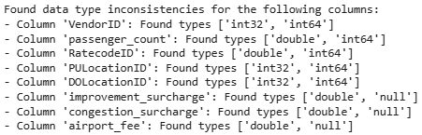 | Column data types were updated to match across all the files:  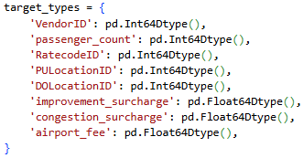
Geographical representativeness | Assess pickup and drop-off distributions across locations and time periods to determine whether the dataset provides sufficient coverage for meaningful analysis and decision-making (Kostakis &Kargas, 2021). | PULocationID, DOLocationID | Shift is observed for pick up and drop off locations, but a steady trend is observed with n outliers when looking at the trends per location.

